Video Git Link:

Project Git Link: <https://github.com/Laura-green008/MobilePlatfrom/tree/master/app/src>

|  |  |  |  |  |  |
| --- | --- | --- | --- | --- | --- |
| Function | Test description | Input | Expected Result | Actual Result | Comments |
| Home Page  Incidents Button | Incidents button navigates to incidents page | Click Incidents button | Incidents page will open | As expected | See img01 |
| Home Page  Roadworks Button | Roadworks button navigates to roadworks page | Click Roadworks button | Roadworks page will open | As expected | See img02 |
| Home Page  Display | Portrait view | Change Orientation | Portrait view for page displayed | As expected | See img03 |
| Home Page  Display | Landscape view | Change Orientation | Landscape view for page displayed | As expected | See img04 |
| Incidents Page  Display | Portrait view  Leave inputs blank | N/A | Any incidents will be displayed | As expected | See img05 |
| Incidents Page  Display | Landscape view  Leave inputs blank | N/A | Any incidents will be displayed | As expected | See img06 |
| Incidents Page  Display | Portrait view  Input correct Road | A96 | Incidents on A96 will be displayed | As expected | See img07 |
| Incidents Page  Display | Portrait view  Input incorrect Road | M8 | As no incidents on M8 error message will be displayed | As expected | See img08 |
| Incidents Page  Display | Landscape view  Input correct Road | A96 | Incidents on A96 will be displayed | As expected | See img09 |
| Incidents Page  Display | Landscape view  Input incorrect Road | M8 | As no incidents on M8 error message will be displayed | As expected | See img10 |
| Roadworks Current  Planned Button | Planned Roadworks button navigates to page | Click Planned Roadworks button | Planned Roadworks page displayed | As expected | See img11 |
| Roadworks Current  Page Display | Portrait view  Leave input Blank | N/A | All Current Roadworks Displayed | As expected | See img12 |
| Roadworks Current  Page Display | Landscape view Leave input blank | N/A | All Current Roadworks Displayed | As expected | See img13 |
| Roadworks Current  Page Display | Portrait Input correct road | A90 | Roadworks on A90 displayed | As expected | See img14 |
| Roadworks Current  Page Display | Landscape  Input correct road | A90 | Roadworks on A90 displayed | As expected | See img15 |
| Roadworks Current  Page Display | Portrait Input incorrect road | Wrigley | Error message stating road either has no works or doesn’t exist displayed | As expected | See img16 |
| Roadworks Current  Page Display | Landscape  Input incorrect road | Wrigley | Error message stating road either has no works or doesn’t exist displayed | As expected | See img17 |
| Roadworks Planned  Page Display | Portrait  Inputs blank | N/A | All planned roadworks will be displayed | As expected | See img18 |
| Roadworks Planned  Page Display | Landscape inputs blank | N/A | All planned roadworks will be displayed | As expected | See img19 |
| Roadworks Planned  Page Display | Portrait  Date entered | 22/04/20 | Roadworks occurring on 22 may will be displayed | As expected | See img20 |
| Roadworks Planned  Page Display | Landscape  Date entered | 22/04/20 | Roadworks occurring on 22 may will be displayed | As expected | See img21 |
| Roadworks Planned  Page Display | Portrait  Correct Road entered | M8 | Roadworks on m8 displayed | As expected | See img22 |
| Roadworks Planned  Page Display | Landscape  Correct Road entered | M8 | Roadworks on m8 displayed | As expected | See img23 |
| Roadworks Planned  Page Display | Portrait  incorrect Road entered | Wrigley | Error message Displayed | As expected | See img24 |
| Roadworks Planned  Page Display | Landscape  incorrect Road entered | Wrigley | Error message  Displayed | As expected | See img25 |
| Roadworks Planned  Page Display | Portrait  Date and road entered | 22/04/20  M8 | Roadworks on m8 on 22 may displayed | As expected | See img26 |
| Roadworks Planned  Page Display | Landscape  Date and Road entered | 22/04/20  M8 | Roadworks on m8 on 22 may displayed | As expected | See img27 |

# Img01

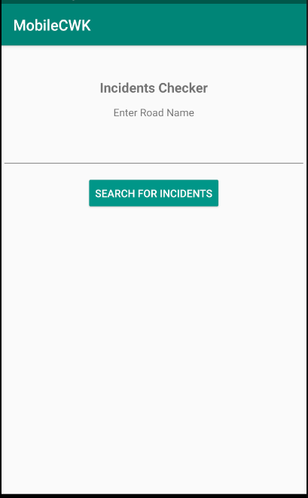

# Img02

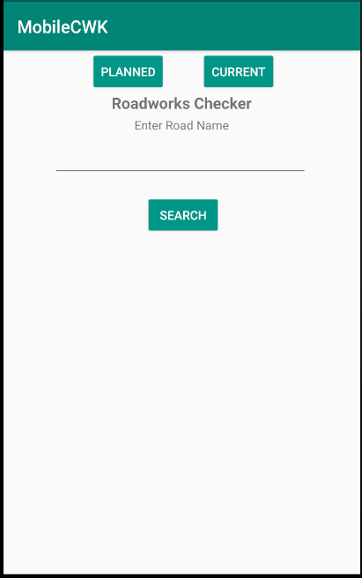

# Img03

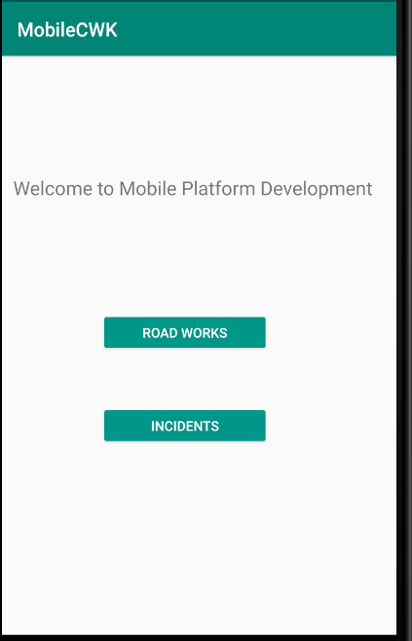

# Img04

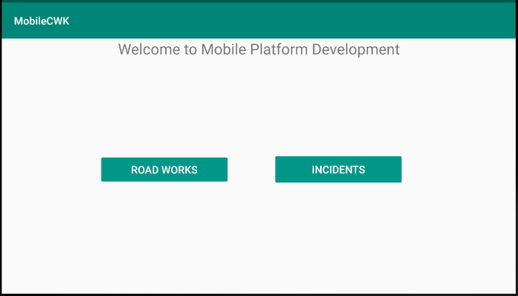

# Img05

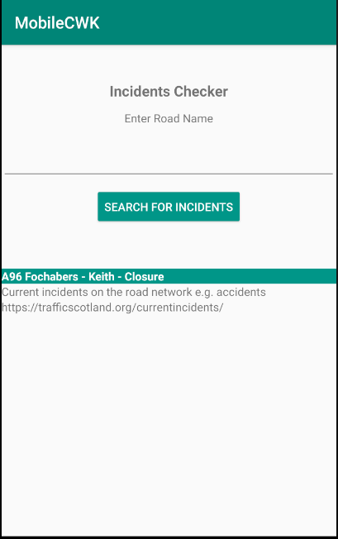

# Img06

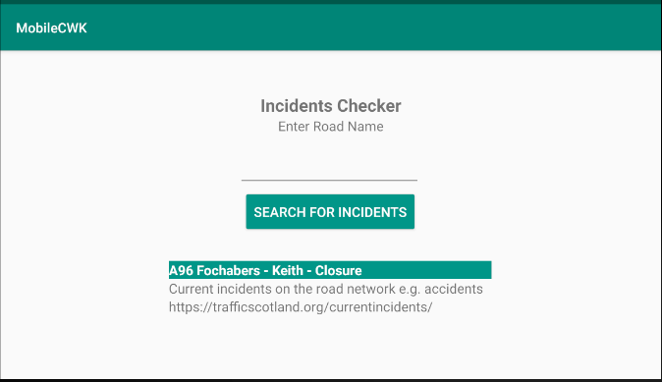

# Img07

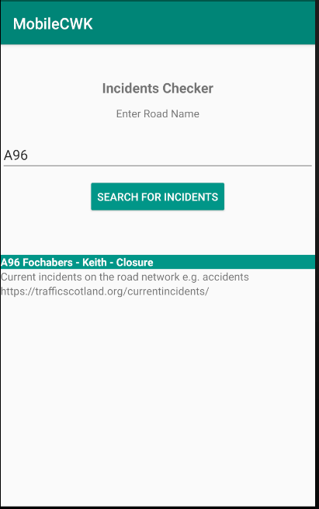

# Img08

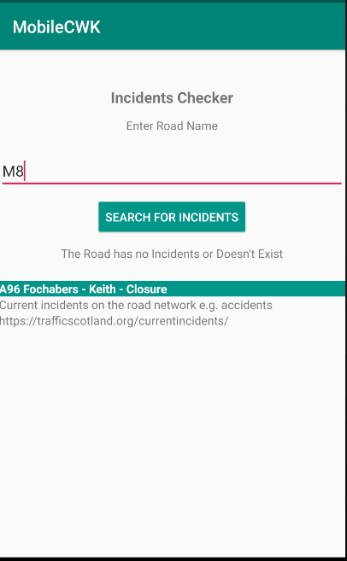

# Img09

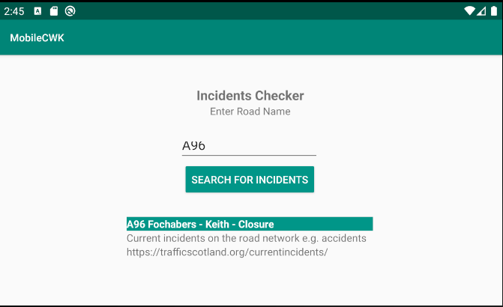

# Img10

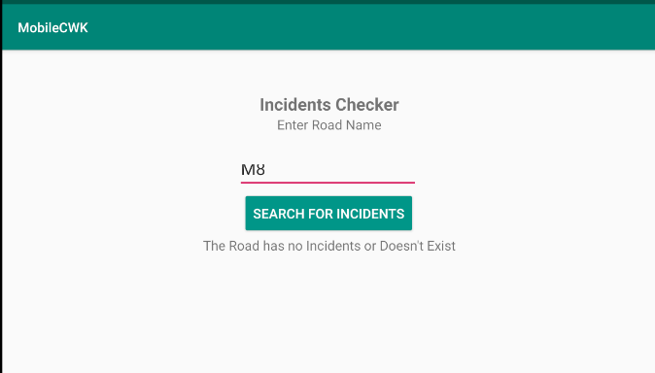

# Img11

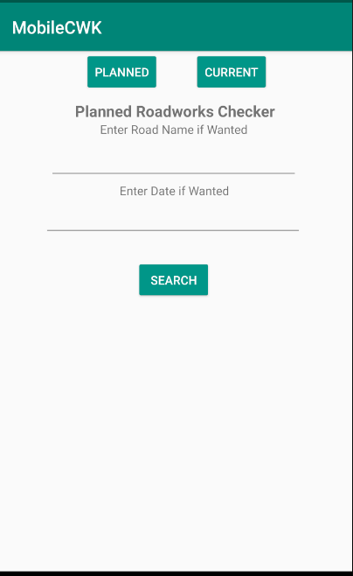

# Img12

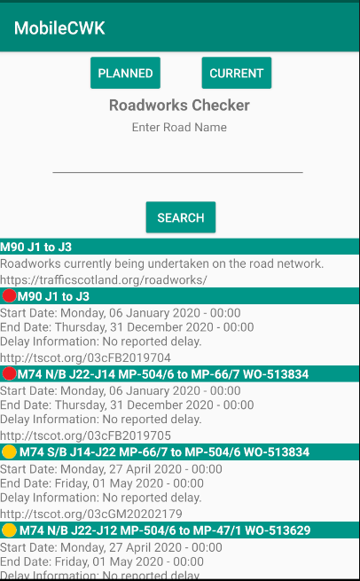

# Img13

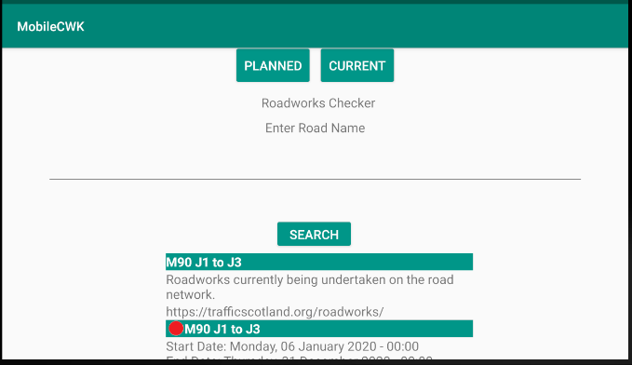

# Img14

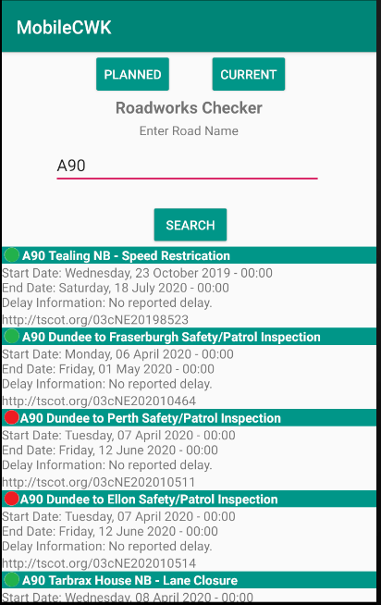

# Img15

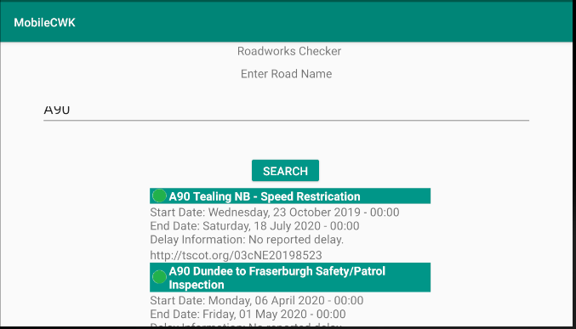

# Img16

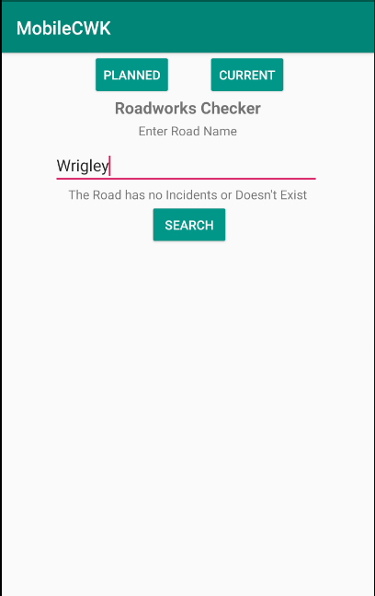

# Img17

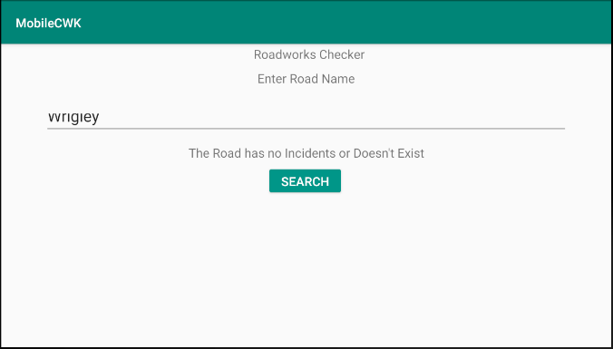

# Img18

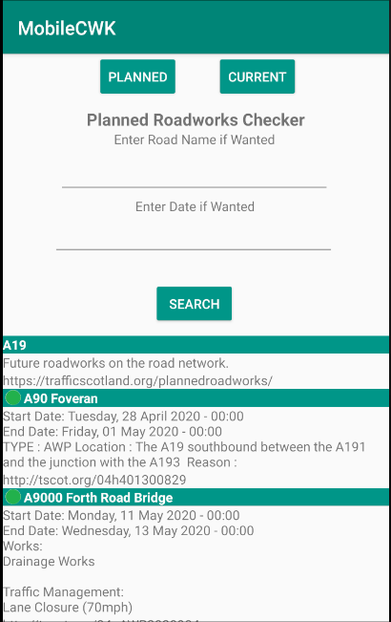

# Img19

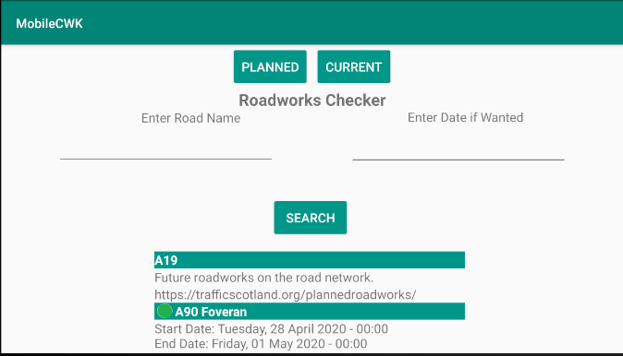

# Img20

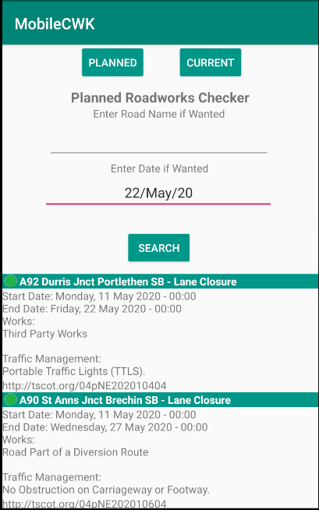

# Img21

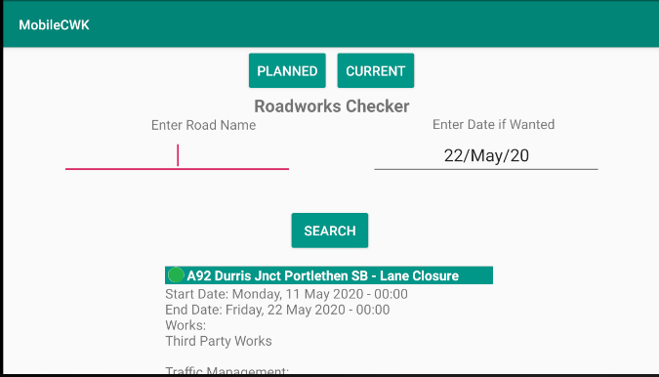

# Img22

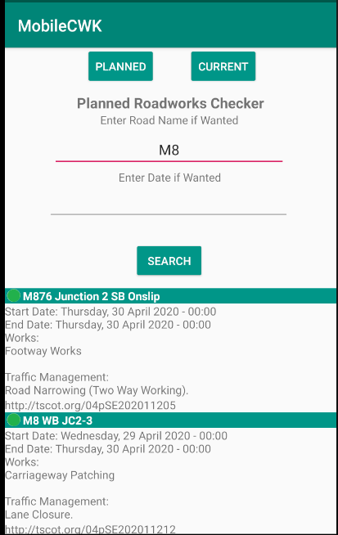

# Img23

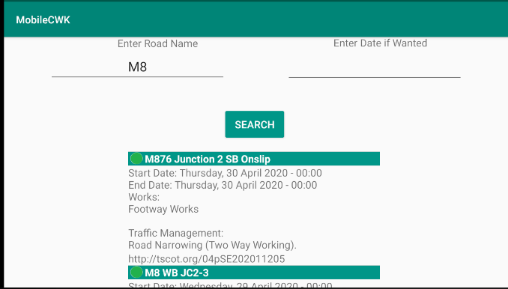

# Img24

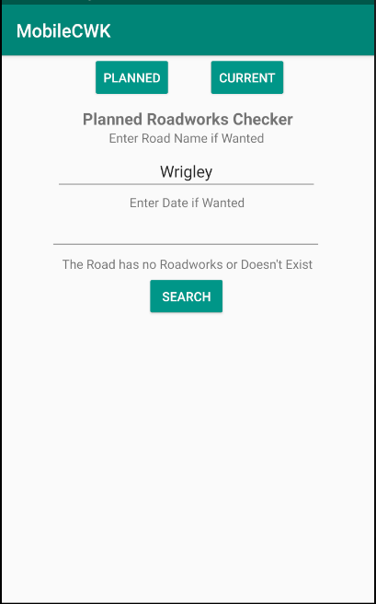

# Img25

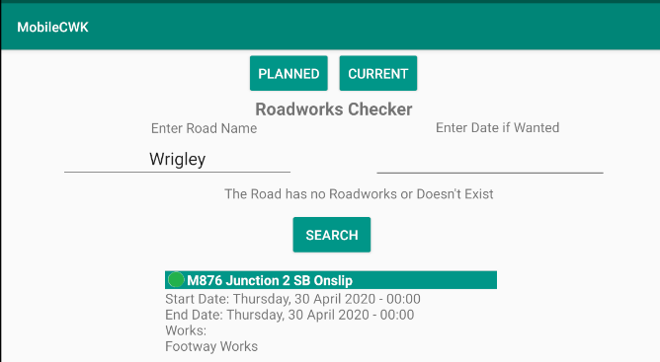

# Img26

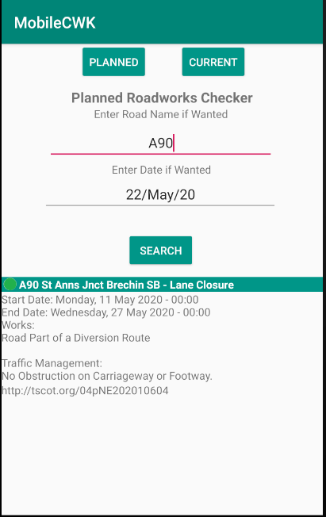

# Img27

